Set Up Instructions for HomeAware
Complete Home Alerting Solution

- Open the box and remove all the items.
- There should be a total of 8 items included:

a. Main Unit
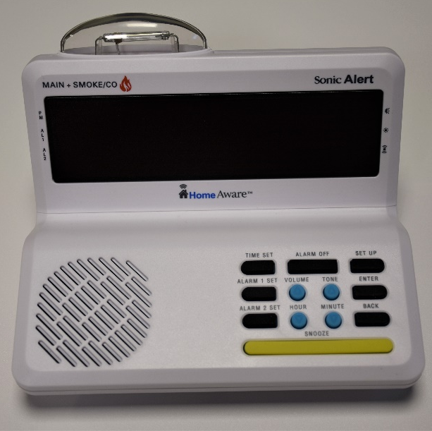
b. Power Supply Cord

c. Bed Shaker d. Phone Line
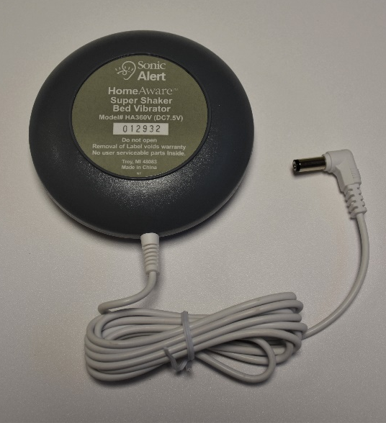

e. Lamp Switch
f. Cell Phone Detector

g. Quick Installation Guide
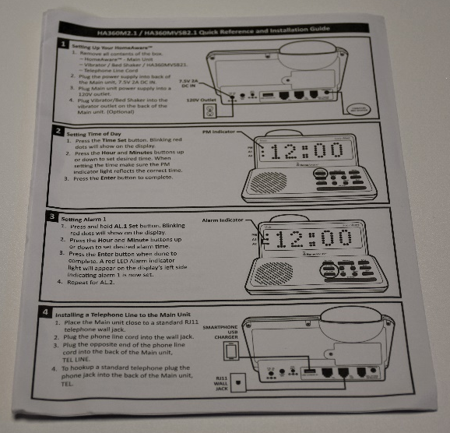
h. User Guide

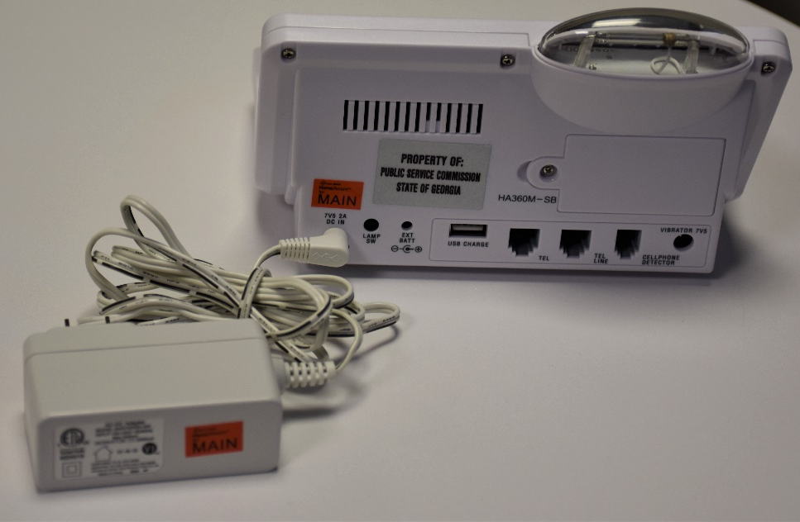
- First, take the Power Supply Cord and plug it into the Main Unit. Then, plug it into the wall.
- Insert one end of the telephone line into the back labeled “TEL. LINE” and the other end into the wall.
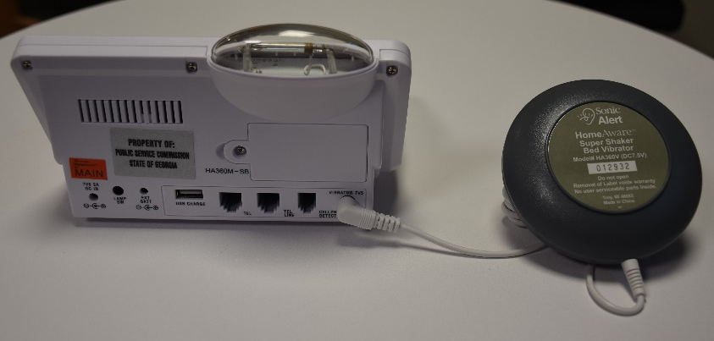
- Then, plug in the Bed Shaker to the back of the Main Unit.
- OPTIONAL: Take the Lamp Switch cord and plug into the back of the Main Unit labeled “LAMP SW”. Connect the other end to your lamp.
- OPTIONAL: Take the Cell Phone Detector and plug into the back of the Main Unit labeled “Cell Phone Detector”.

How To Use:
- Time Set button:
  - This is used to set the time on the clock face
- Hour button:
  - This button is used to set the hour number on the clock
- Minute button:
  - This is used to set the minute
numbers on the clock
- Enter button:
  - This is used to finalize the time. Press this button when you finish selecting the time you desire.

- Alarm Off button:
  - This is used to end an
alarm when it is going off

- Alarm 1 Set button:
  - This is used to set up an alarm time. Use the Hour and Minute buttons to set up the time like
with the Time button.
- Alarm 2 Set button:
  - This is used to set a
second alarm time.
- Volume button:
  - This controls the volume level.
  - There are 8 levels and an off level.
- Tone button:
  - This button is used to skim through different settings.
**The user guide will walk through every option for this button

- Back button:
  - This button is used to return to the previous screen you were on.
  - When pressed at the same time as the Enter button, the word “Test” will show on the screen. The audio, flash, and lamp should all activate to ensure they are all functioning correctly.

- Snooze button:
  - This button is used to temporarily pause an alarm.
  - Press this button to also end the test mode.

Setting Up Time and Alarms:
- To set up the time of day:
  - Press the Time Set button and red dots should blink to indicate that it is activated.
  - Press the Hour button to adjust the hour and the Minute button to adjust the minutes. There is a PM indicator that will light up when the time is set for pm.
  - Press the Enter button to finish.
- To set up alarm times:
  - Press and hold the AL. 1 Set button. Red dots should blink to indicate it is activated.
  - Press the Hour button to adjust the hour and the Minute button to adjust the minutes.
  - Press the Enter button to finish. A red dot will light up next to the AL. 1 indicator.
  - To set up Alarm 2, follow the same steps above.

- To turn off an alarm:
  - Press the Alarm Off button to turn off.
  - Press the Snooze button to temporarily pause the alarm.
- To set the alarm duration:
  - Press the Set Up button and the word LINK will appear on the screen.
  - Press the Tone button and the word CLOCK will appear on the screen.
  - Press the Enter button. Then, the word ONTIME will show on the screen. Press Enter again.
  - Press the Tone button to set the alarm duration. This ranges from 5 minutes to 30 minutes. Press Enter to finish.
- To set the snooze duration:
  - Press the Set Up button and the word LINK will show on the screen.
  - Press the Tone button and the word CLOCK will show on the screen. Press the Enter button.
  - Then, the word ONTIME will appear on the screen.
  - Press the Tone button until you see the word SNOOZE appear on the screen. Press Enter.
  - The snooze duration is automatically set to 10 minutes. Press Enter to set it for this length.
  - To adjust the duration, press the Tone button until it displays the time length you desire.
- To set up the flashing alarm:
  - Press the Set Up button and the word LINK will show on the screen.
  - Press the Tone button and the word CLOCK will appear.
  - Press the Tone button repeatedly until you see the word FLASH appear. Press Enter.
  - Press the Enter button and the word ON will show.
  - Press the Tone button to switch it back and forth to ON or OFF. Press Enter to finish your selection.
- To set up the audio alarm:
  - Press the Set Up button and the word LINK will be shown.
  - Press the Tone button and the work CLOCK will be shown. Press Enter.
  - Then, press the Tone button until the word ALARM1 is shown.
  - Press the Enter button and the word VIBR will appear.
  - Press the Tone button and the word AUDIO will appear. Press Enter.
  - Press the Tone button to go between the ON or OFF setting. Press Enter to finish your selection.
- To set up the Bed Shaker alarm:
  - Press the Set Up button and the word LINK will appear.
  - Press the Tone button and the word CLOCK will show. Press Enter.
  - Press the Tone button until the word ALARM1 appears.
  - Press the Enter button and the word VIBR will show. Press Enter.
  - Press the Tone button to go between the ON or OFF options.
  - Press Enter to finish your selection.
- To select 12 or 24 hour mode:
  - Press the Set Up button and the word LINK will show.
  - Press the Tone button and the word CLOCK will be shown. Press Enter.
  - Press the Tone button until 12/24 is shown. Press Enter.
  - Press the Tone button to go between the 12 Hour or 24 Hour options. Press Enter to finish your selection.

How to Set Up the Cell Phone Detector:

- First, plug in the Cell Phone Detector into the back of the Main Unit.
- On your smartphone, go to the app store and search for the app “HomeAware”.
- Then click the “Get” button and download the app on to your phone.

- The app will walk you through how to use it.

